CPSC 1181, Lab Assignment 8

Objectives
- GUI
- Exceptions

Requirements
Write a program which gets as input a string from a text field, representing a date in the form DD/MM/YY (for instance 03/02/01).
Your program should produce an error message if a date item is non-numeric, is missing completely or specifies an impossible date. Ignore leap years.
Your program should produce a GUI with a label, a text field and a button as shown below. When the Verify Date button is pressed your program should read the date from the text field and verify it.
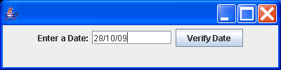
If the date entered is correct, a popup window should notify the user that the date is correct (using the JOptionPane.showMessageDialog method).
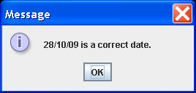
In the case of errors, exceptions must be thrown, and appropriate error messages must be displayed in a pop up window. Create a new exception class called InvalidDateException, and throw it if an invalid date is entered.
